Exercise #3

- List all employees whose last names begin with P.

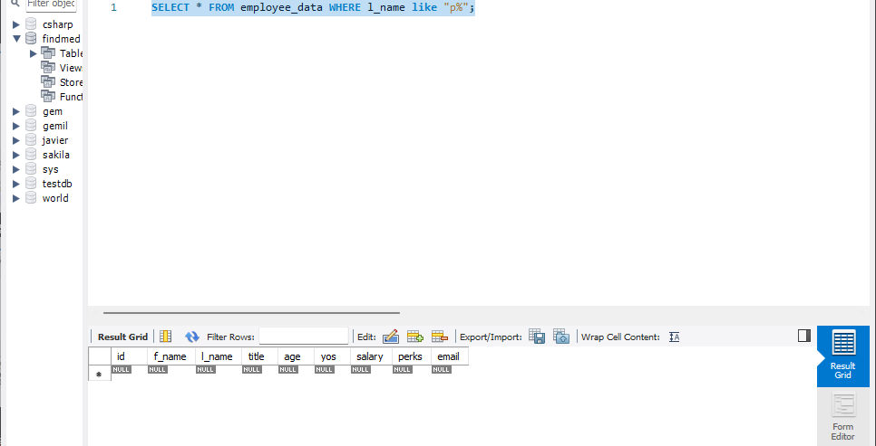
- Display the names of all employees in the marketing division

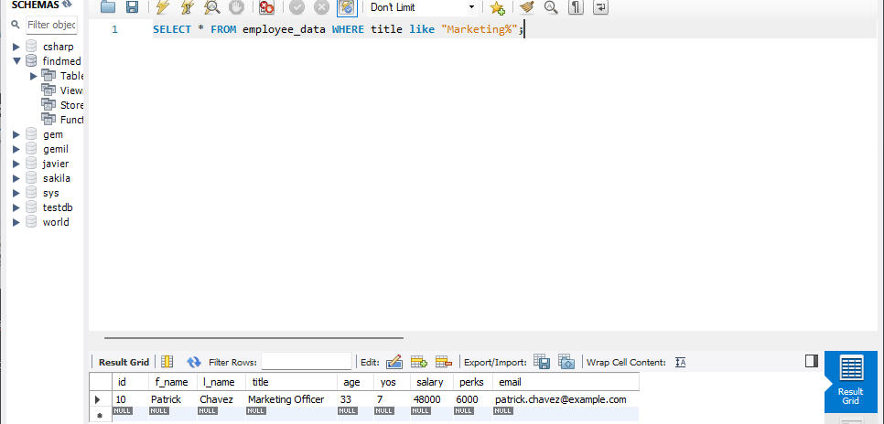

- What will the following statement display:
SELECT f_name, l_name, Salary from employee_data where f_name like '%k%';
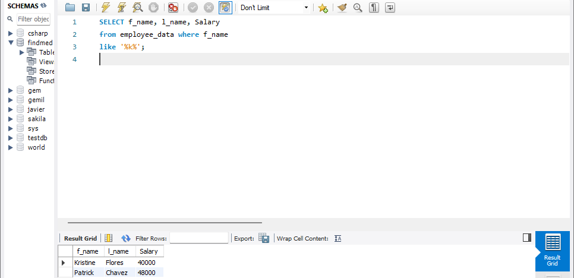
-- It displays the first name, last name and salary of all employees that has at least one k on their first name.

- List the last names and titles of all programmers
SELECT f_name, l_name, Salary
from employee_data where title
like '%Programmer%';

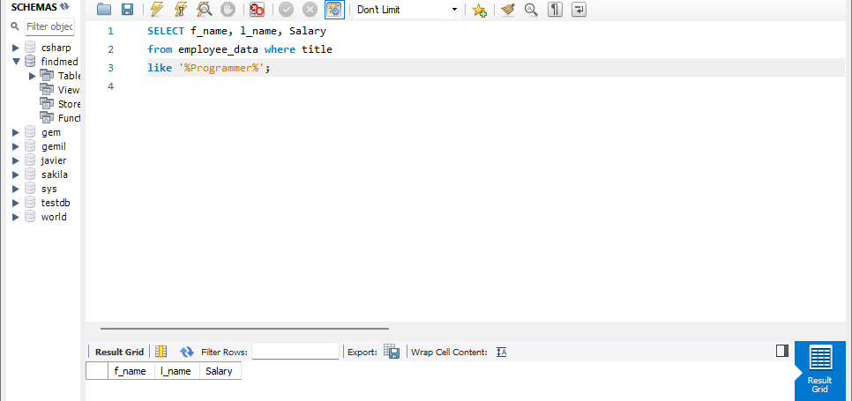
-- Again, I’m just working with what I have.

